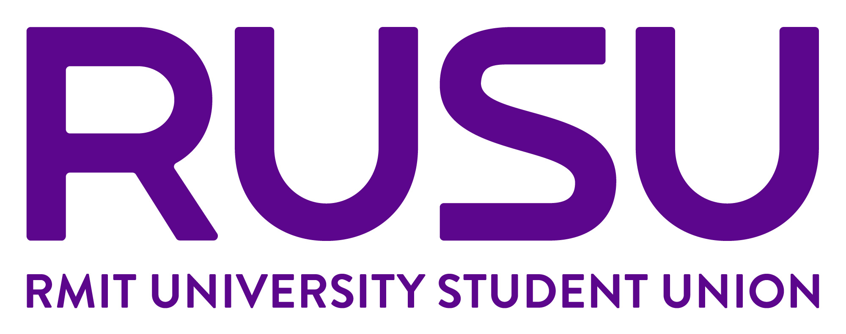
Realfoods CASUAL Application – Additional Information
Please complete the following form and email it along with your CV to rusu.jobs@rmit.edu.au before 9 am Monday 7 July.
*Applicants MUST be RMIT students in semester 2,2025 & MUST have minimum 1 year experience as a barista/all-rounder.
Name

Email
Are you a Current RMIT student?
Program name & year level
Campus
Home suburb during semester
Availability – Tell us SPECIFICALLY when you are available between 8.30am and 4.30 pm Mon to Thurs | Mondays  Tuesdays  Wednesdays  Thursdays
Barista Experience
Briefly outline your professional experience working with coffee, latte art, grind adjustment
Food Preparation & Service Experience. This role requires food preparation and food service. Briefly outline your experience.
Experience with vegetarian/ vegan food/sustainability Briefly outline any experience you have working with vegan and vegetarian food
Volunteer experience at RUSU/RMIT/Community
Do you have a current Food Safety Certificate?
Do you have a valid Visa to work in Australia?
Briefly outline why you are interested in working at Realfoods (no more than 150 words)

